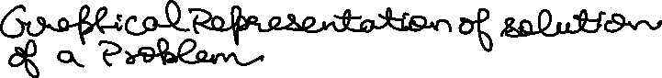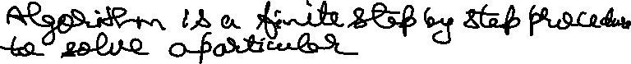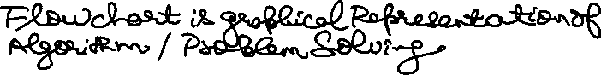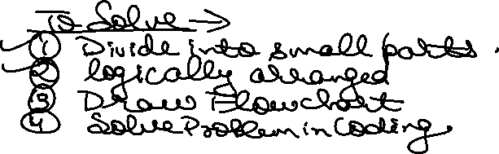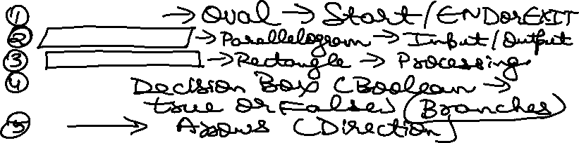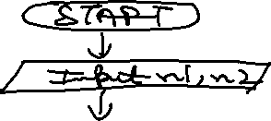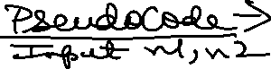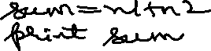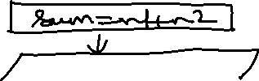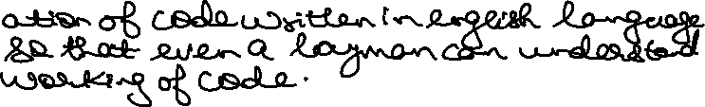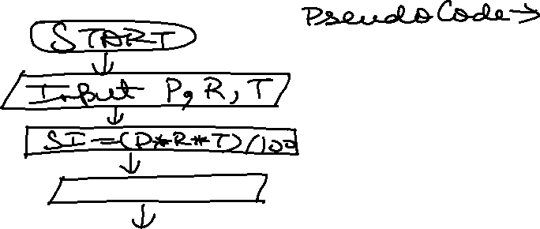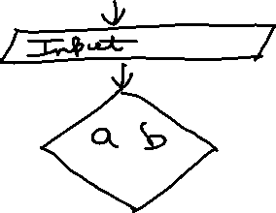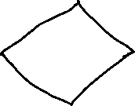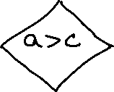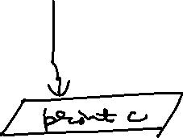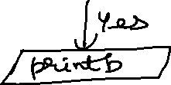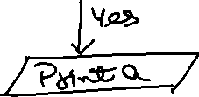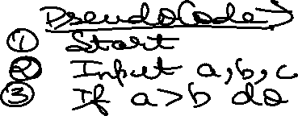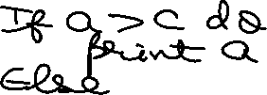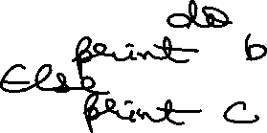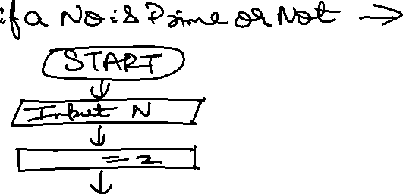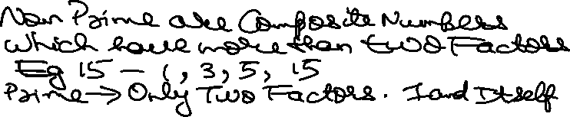

import java.util.Scanner;

public class Prime {

    public static void main(String[] args) {

        Scanner input = new Scanner(System.in);

        System.out.println("Enter the Value of Number = ");

        boolean Prime = true;

        int N = input.nextInt();

        for(int i = 2 ; i < N ; i++){

            if(N % i == 0){

                Prime = false;

                break;

            }

        }

        if(Prime==false){

            System.out.println(N + " is Not a Prime Number");

        }else{

            System.out.println(N + " is a Prime Number");

        }

        input.close();

    }

}

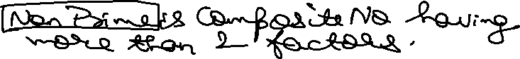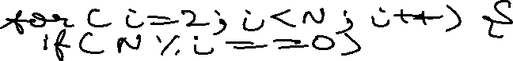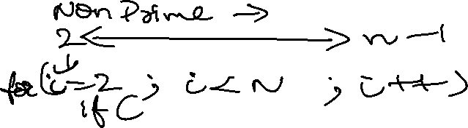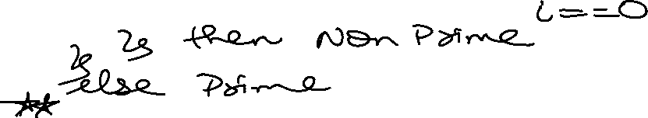

Your code for checking whether a number is prime or not is quite straightforward and functional! Let’s break it down:

1. You’ve used a Scanner to read input from the user, which is a good approach.
2. The variable Prime is used to track whether the number is prime or not.
3. The loop iterates from 2 to N-1, checking if N is divisible by any number in that range.
4. If N is divisible by any number, you set Prime to false and break out of the loop.
5. Finally, you print whether the number is prime or not based on the value of Prime.

However, there are a couple of improvements you can make:

1. **Optimization**: You can reduce the loop range from 2 to Math.sqrt(N) to improve efficiency. If N is divisible by any number greater than its square root, it will also be divisible by a smaller factor.
2. **Edge Cases**: Consider handling cases where N is less than 2 (since prime numbers start from 2) and printing an appropriate message.

Here’s an updated version of your code with these improvements:

import java.util.Scanner;

public class Prime {

public static void main(String[] args) {

Scanner input = new Scanner(System.in);

System.out.print("Enter a positive integer: ");

int N = input.nextInt();

input.close();

if (N < 2) {

System.out.println(N + " is not a prime number.");

return;

}

boolean isPrime = true;

for (int i = 2; i <= Math.sqrt(N); i++) {

if (N % i == 0) {

isPrime = false;

break;

}

}

if (isPrime) {

System.out.println(N + " is a prime number.");

} else {

System.out.println(N + " is not a prime number.");

}

}

}

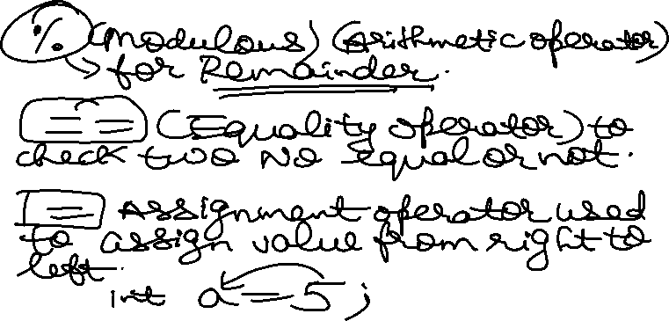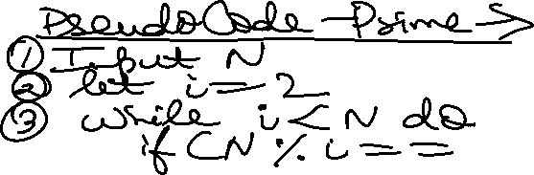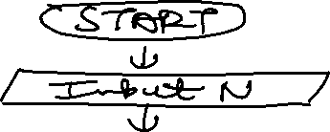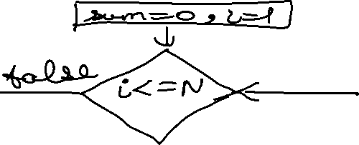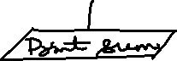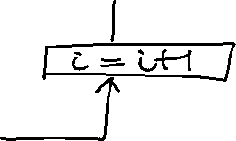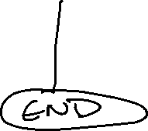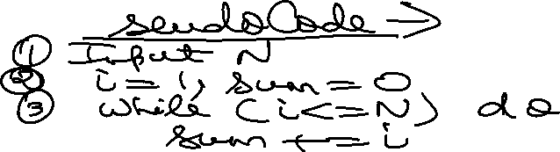

import java.util.Scanner;

public class SumofNaturalNo {

    public static void main(String[] args) {

        Scanner input = new Scanner(System.in);

        System.out.println("Enter Value of Number = ");

        int N = input.nextInt();

        int sum = 0;

        // Loop to calculate sum of N Natural Numbers ->

        for(int i = 1 ; i<=N ; i++){

            sum += i;

        }

        System.out.println("Sum of N Natural Numbers = "+sum);

        input.close();

    }

}